**Content**

1. Nadpis 1 3

1. Intro

Threejs.org/docs

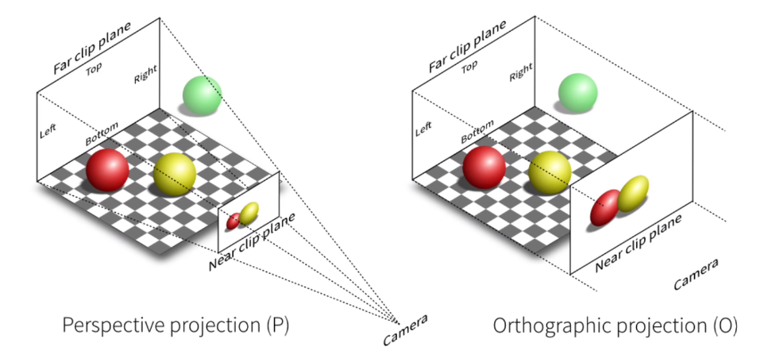

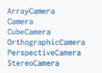

Near clip plane – anything closer will be not displayed

Far clip plane – anything further will be not displayed.